Step-by-Step Guide to Creating a Resume

Your resume is your chance to impress an employer with what you know and what you have accomplished. An Employer Competitive resume is persuasive because it is focused on results, uses dynamic language, is organized, visually clean, and free of grammatical errors.

This document will walk you through the steps to create a resume. If you already have a resume, you may want to just review this document and use it as a guide to update your resume.

To help you get started, we are providing several resume samples for you to take a look at what makes them distinct from one another as well as what information the writer chose to include.

**An Employer Competitive Resume includes the following sections:**

* Candidate name, phone number, and email address
* Live links to your LinkedIn Profile, Github, and Portfolio with deployed projects
* Concise and compelling brand statement
* List of relevant technical skills
* List of deployed projects or applications built
* Career history/work experience
* Education

**Your resume should be no more than 1-2 pages.**

* If you do not have relevant technical experience, then keep your resume to under 1 page.
* If you do have relevant technical experience and need additional space, you can go up to 2 pages.

**Step 1: Set Up Your Resume**

* Save your resume with a professional title: FirstName LastName Resume
  + E.g. JohnDoeResume OR JohnDoe_Resume
* Create a clear header:
  + Name
  + Telephone Number
  + Professional email address (e.g. not hotmail, yahoo, aol or school)
  + City & State
  + Links to your online documents, clearly labeled
    - LinkedIn
    - Portfolio
    - GitHub

**Sample**​

**Step 2: Write a Career Summary**

* Use your brand statement as the starting point.
* It should be between 3-5 lines
* Do not use pronouns or first-person point of view.
* Present yourself as a professional, not as a student.

**Sample**

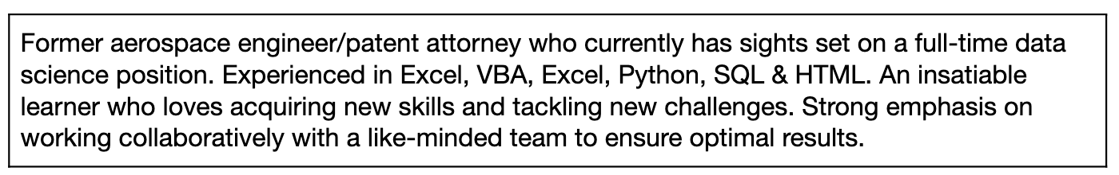

**Step 3: List Your Technical Skills**

* Write a short list of those skills gained through experience or training. Include all transferable skills, not only the skills specific to coding languages and tools.
* Use keywords and specific skill-sets that are relevant to the job you are targeting.
* Recruiters and Human Resource departments use Application Tracking Systems (ATS) to scan and filter resumes based on keywords.
  + Recruiters and Human Resource departments use Application Tracking Systems (ATS) to scan and filter resumes based on keywords. [Here](https://careerservices.gitbook.io/career-resources-data-analytics-library/-LjRMfertuZzhAIzJI8A/er-milestone-create-professional-materials/guide-to-applicant-tracking-systems) is a helpful resource to better understand ATS.

**Sample**

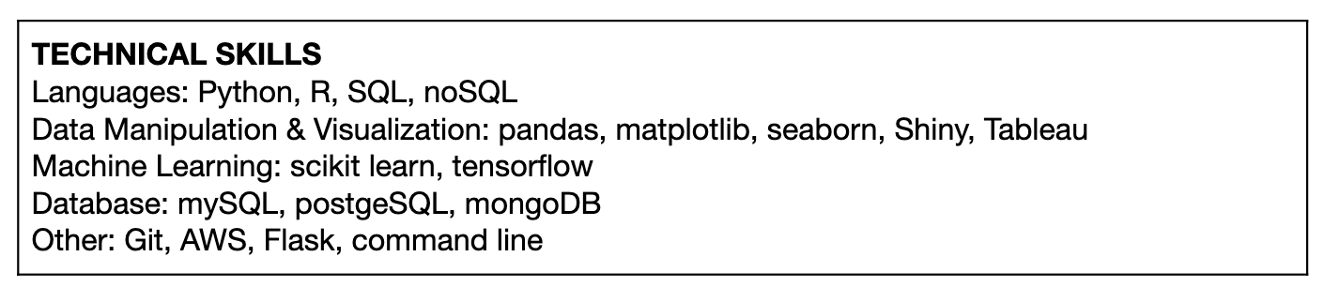

**Step 4: List the Projects & Applications You’ve Built**

* List up to 3 of your strongest projects (these may be homework assignments) that demonstrate your knowledge, skills, and abilities as a developer, NOT a student.
* Include a description, the languages used, and a direct link to the code:
  + Project Name
  + Role in the Project
  + Description of Project
  + Language & Tools Used
  + Link to code or deployed site or both
* The project description should be a maximum of 1 line - focus on selling your skills.

**Sample**

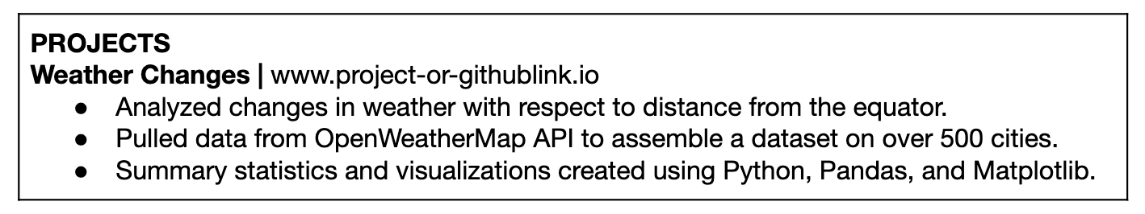

**Step 5: List Your Experience**

* List your experience in reverse chronological order with the most recent first.
  + Include job title, job description, company name, city and state, dates of employment. Be consistent with the use of dates and date ranges throughout the resume. For example, pick a standard format for your dates (6/15, or 06/2015, or June 2015), and use it consistently.
    - As a general rule of thumb, do not abbreviate months with fewer than four letters.
  + For each experience, list no more than 3-5 bullet points or a short paragraph.
    - Start with an action verb. For all past employment, use the past tense. For current employment, use the present tense.
    - List accomplishments, not daily action items. See “[How to Turn Your Duties into Accomplishments](https://www.themuse.com/advice/resume-revamp-how-to-turn-your-duties-into-accomplishments)” for ideas.
    - It’s fine to either use periods or not use them at all, but be consistent throughout your resume. If you use a period on one bullet point, use a period on all bullet points.

**Sample**

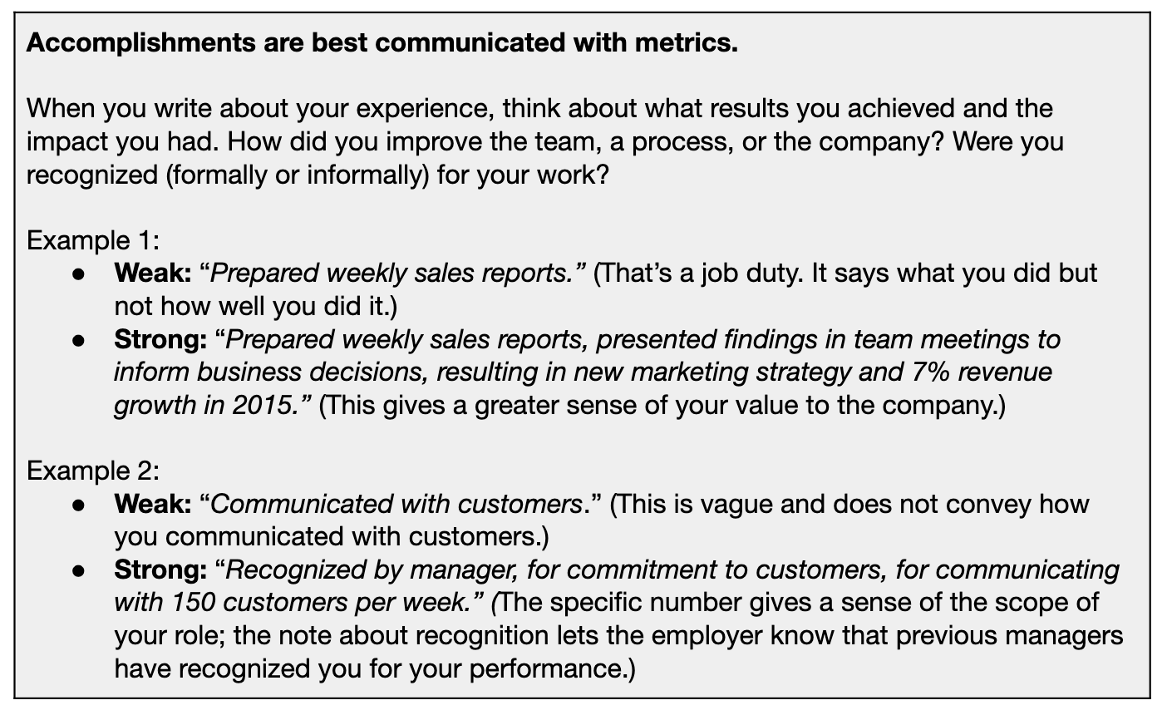

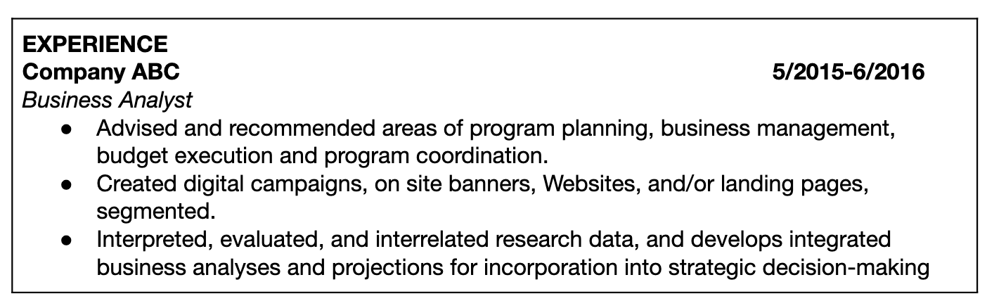

**Step 6: List Your Education**

* List education in reverse chronological order, with most recent first. Your Bootcamp should be listed first.
  + - There are two exceptions to this rule— if you have limited professional experience or you have a degree in Computer Science, Engineering, or other STEM fields.
      * For either of these exceptions, you may opt to include your education below your professional summary.
  + List all locations, and certifications received

**Sample**

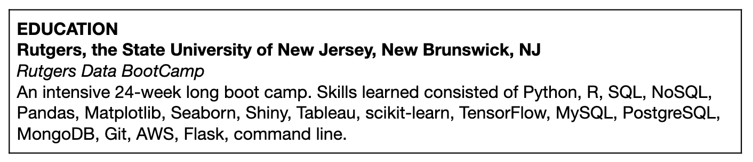

**Step 7: Format and Style the Resume**

Once your content is created, you can focus on presentation.

* Review the resume templates to find one you like most. Once you have chosen a style, insert your text.
* Make sure all font is consistent in size, style, and easy to read.
  + Serif: Georgie, Bell MT, Goudy Old Style, and Garamond
  + Sans serif: Arial, Tahoma, Century Gothic, and Lucida Sans
* Ensure your name and headlines stand out, using bold, italics, capitalization, underlining or slightly larger font sizes to help.
* Use consistent bullet point style, and avoid hanging lines (when just a few words take up an entire line).
* Be mindful of your tone. It should be reader-friendly and professional. Avoid casual jargon or superlative adjectives like “great", “good”, and “awesome.”
* Check for consistent punctuation.
* Check grammar and spelling.
* Avoid personal pronouns, abbreviations, and acronyms.